
AMERICAN INTERNATIONAL
UNIVERSITY-BANGLADESH
Faculty of Science and Technology

Assignment

Assignment Title: | Computer Networks Manual
Assignment No: | 01 |  | Date of Submission: | 19 November 2025
Course Title: | Computer Networks
Course Code: | COE 3204 |  | Section: | F
Semester: | Fall | 2025-26 | Course Teacher: | DR. RAJARSHI ROY CHOWDHURY

Declaration and Statement of Authorship:
- I/we hold a copy of this Assignment/Case-Study, which can be produced if the original is lost/damaged.
- This Assignment/Case-Study is my/our original work and no part of it has been copied from any other student’s work or from any other source except where due acknowledgement is made.
- No part of this Assignment/Case-Study has been written for me/us by any other person except where such collaboration has been authorized by the concerned teacher and is clearly acknowledged in the assignment.
- I/we have not previously submitted or currently submitting this work for any other course/unit.
- This work may be reproduced, communicated, compared and archived for the purpose of detecting plagiarism.
- I/we give permission for a copy of my/our marked work to be retained by the faculty for review and comparison, including review by external examiners.
- I/we understand that Plagiarism is the presentation of the work, idea or creation of another person as though it is your own. It is a formofcheatingandisaveryseriousacademicoffencethatmayleadtoexpulsionfromtheUniversity. Plagiarized material can be drawn from, and presented in, written, graphic and visual form, including electronic data, and oral presentations. Plagiarism occurs when the origin of their arterial used is not appropriately cited.
- I/we also understand that enabling plagiarism is the act of assisting or allowing another person to plagiarize or to copy my/our work.

* Student(s) must complete all details except the faculty use part.
** Please submit all assignments to your course teacher or the office of the concerned teacher.

Group Name/No.:

No | Name | ID | Program | Signature
1 | Chinmoy Guha | 22-48056-2 | CSE
2 | Mohammad Ansar Uddin | 22-47975-2 | CSE

Faculty use only
FACULTY COMMENTS | Marks Obtained
 | Total Marks

Lab -1:
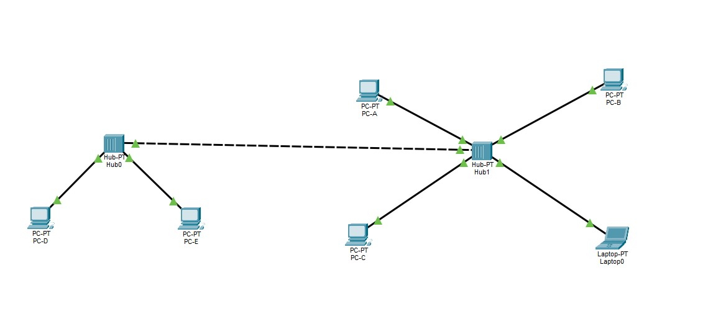
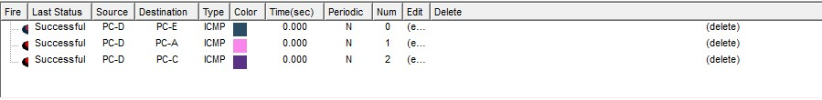

The first CN lab class. For this lab exercise, I set up a simple computer network by connecting two hubs together. Several PCs and a laptop were attached to the hubs, forming two small network segments. I then used a crossover cable to link the segments so that every device could communicate with one another.

Lab-2:

Task-1:
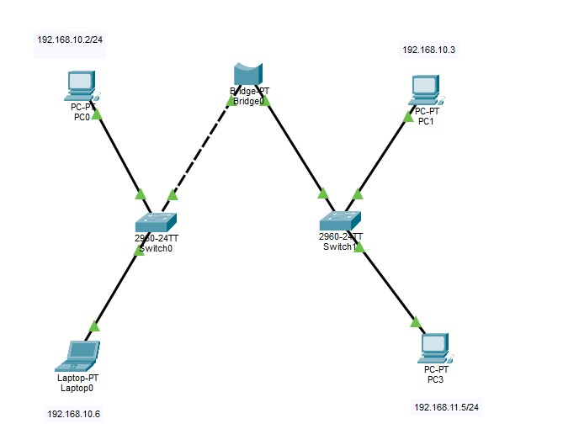

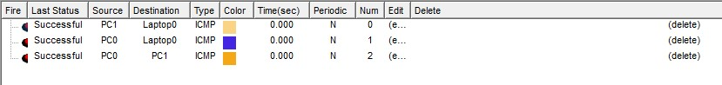

In this lab exercise, I built a network using two switches that were interconnected via a PT-Bridge. I connected several PCs and a laptop to the switches and assigned IP addresses from two separate subnets. The bridge enabled the two segments to communicate with each other. Afterwards, I configured the end devices and confirmed that connectivity worked across the entire network.

Task-2:
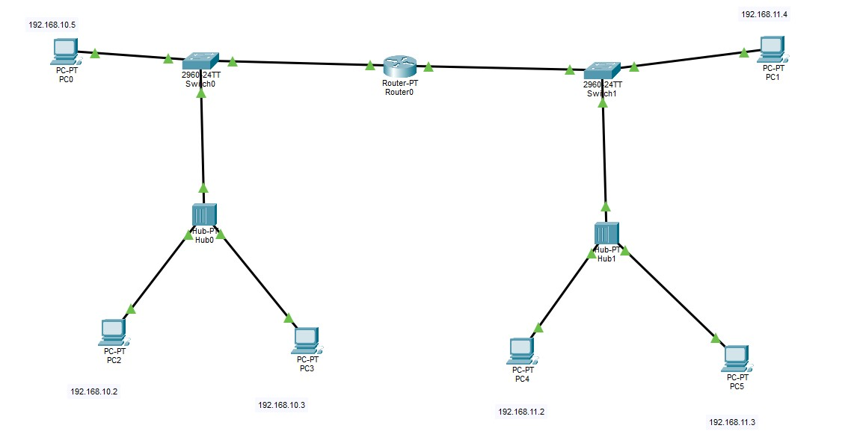

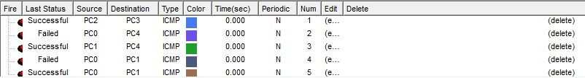

In this lab activity, I set up a network made up of two distinct LANs connected by a PT-Router. Each LAN included a switch attached to a hub, which provided connections for several PCs. I assigned IP addresses from two separate subnets to the devices in each LAN, and configured the router to allow communication between the two networks.

Lab-3
Task-1:
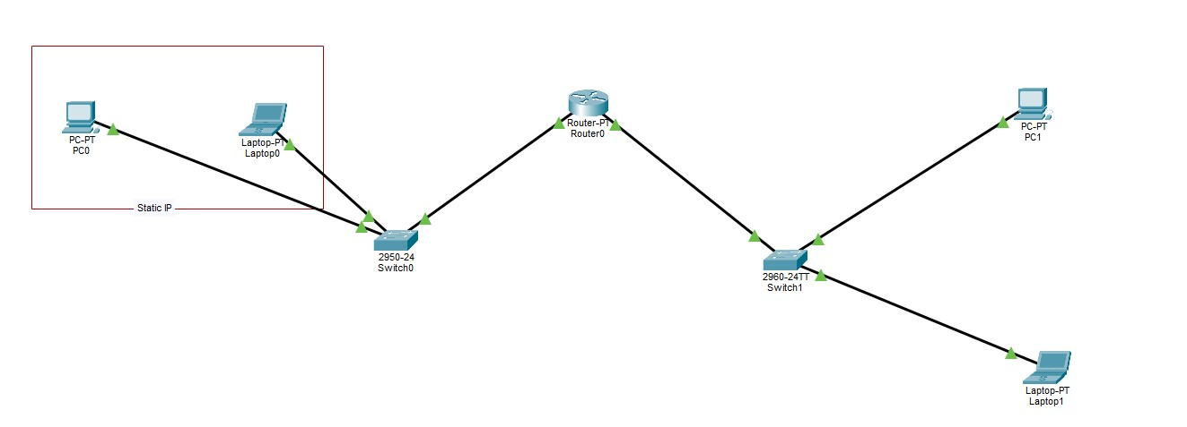
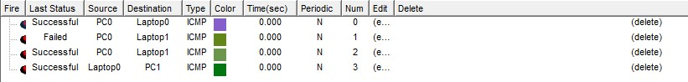

In this lab task, I set up a network comprising two switches linked via a PT-Router to facilitate communication between separate segments. On one side, a PC and a laptop with static IP addresses were connected to Switch0. On the opposite side, another PC and laptop were linked to Switch1. The router, positioned between the switches, handled the routing of data between the two network segments, enabling inter-device communication across the network.

Task-2:
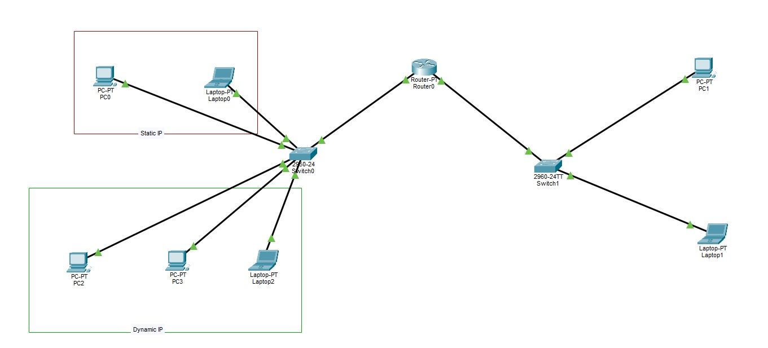

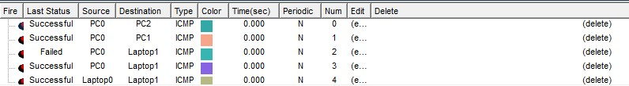

In this lab task, I designed a mixed network configuration that combines both static and dynamic IP addressing methods. On the left side, a PC and a laptop were manually assigned static IP addresses, while devices in the lower section obtained their IPs automatically via DHCP. All of these devices are connected to Switch0, which is linked to a router for broader network connectivity. On the right side, an additional switch connects more PCs and a laptop. All switches, PCs, and laptops are ultimately connected through a PT-Router, ensuring unified communication across the entire network.

Task-3:
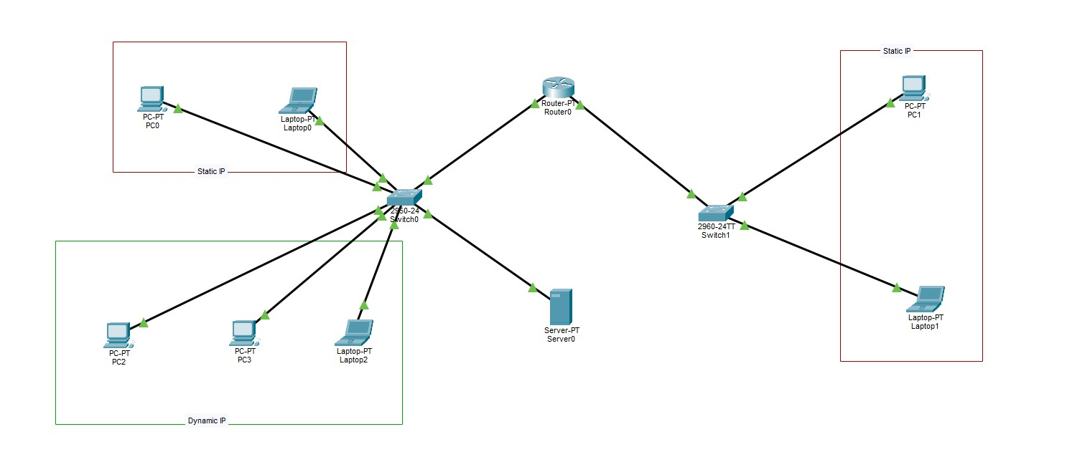
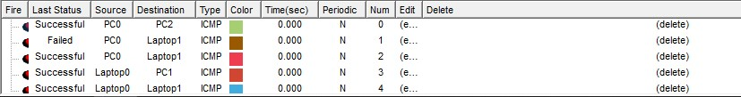

In this lab task, I implemented a network setup that incorporates both static and dynamic IP configurations. On the left side, a PC and a laptop were assigned static IP addresses, while several devices in the lower section obtained their IPs automatically via DHCP. All of these devices are connected to Switch0, which is also linked to a server providing additional network services. A router connects Switch0 to another switch on the right side, which hosts more devices using static IPs, enabling structured communication across the network.

Task-4:
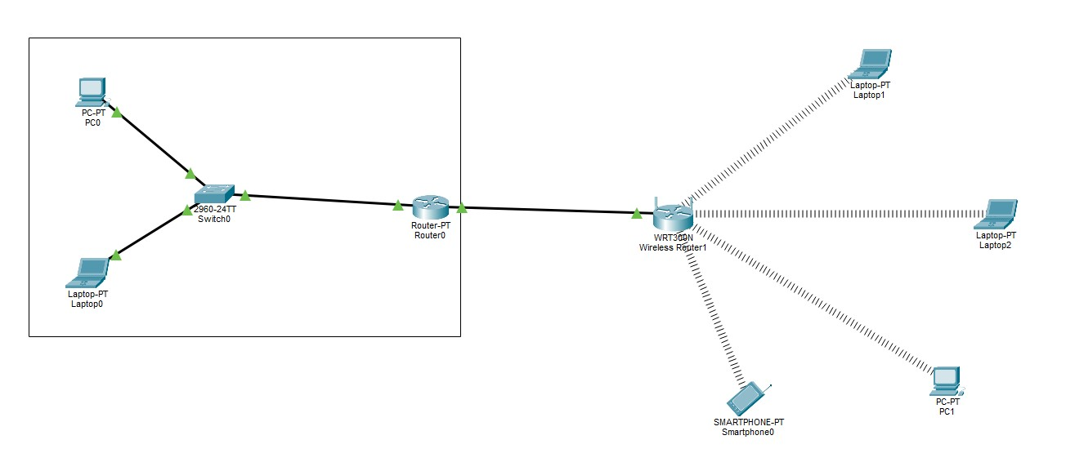
In this lab task, I set up a mixed wired and wireless network. On the left side, a PC and a laptop were connected to Switch0, which is linked to a router handling the network's routing functions. This router is further connected to a WRT300N wireless router that provides Wi-Fi access. Multiple wireless devices—including laptops, a smartphone, and a PC—connect to the network through this wireless access point, enabling seamless wireless communication.

Task-5:
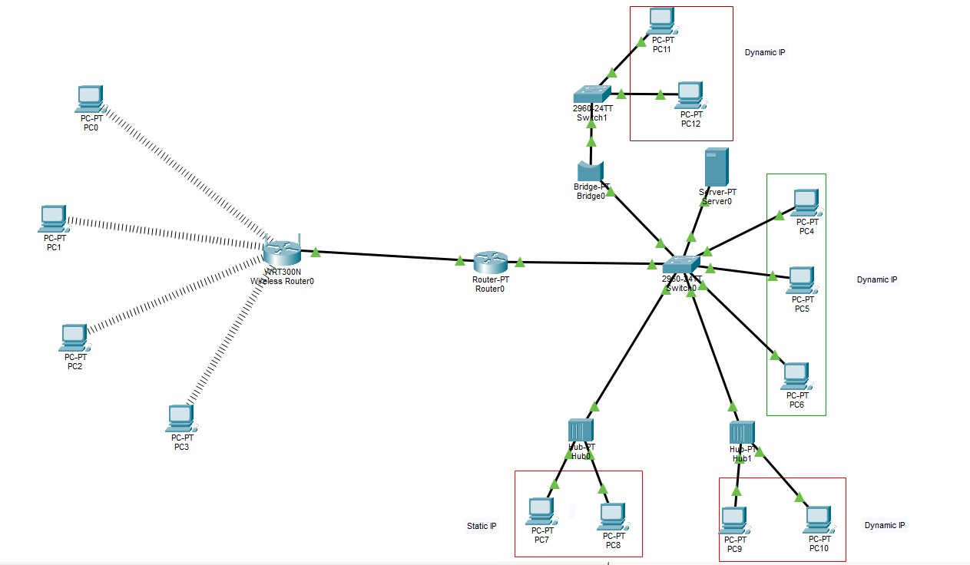
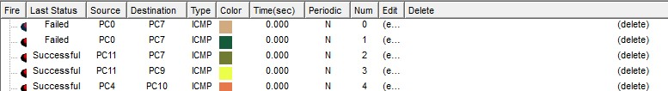

In this lab task, I built an extended network that integrates both wired and wireless components, using a combination of static and dynamic IP addressing. Several wireless PCs connect to a WRT300N wireless router, which is linked to a main router responsible for overall network routing. The main router is connected to Switch0, which distributes connections to various DHCP-enabled devices, a server, and multiple hubs. Static-IP PCs are connected via Hub0 and Hub1. To further expand the network, I incorporated a bridge and an additional switch, allowing more dynamic-IP devices to be connected efficiently.

Lab-4
Task-1:
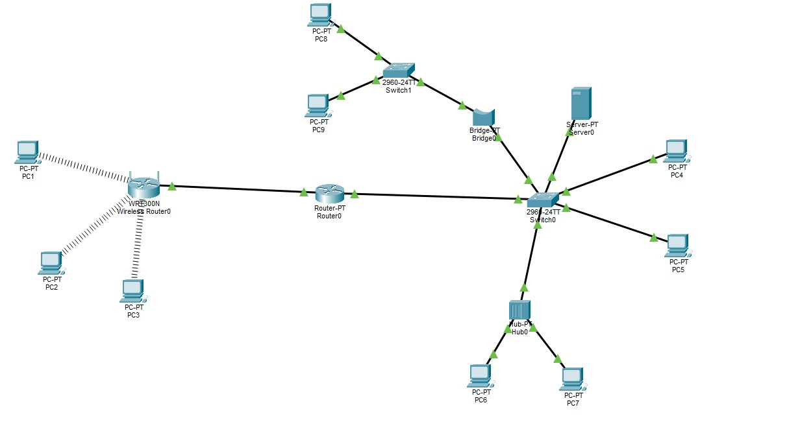

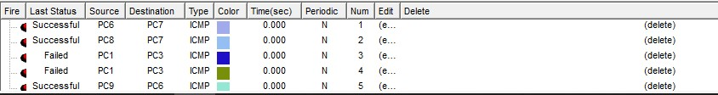

In this lab exercise, I designed a multi-layer network topology that incorporates multiple layers using routers, switches, and wired connections to support structured communication across various subnets. A core switch serves as the central hub, linking to multiple distribution switches that connect to several PCs. A primary router facilitates inter-subnet communication, effectively routing data across the entire network. Depending on the segment, PCs are configured with either static or dynamic IP addresses. Additional switches and interconnected routers are included to expand the network and optimize data flow. This setup showcases a scalable and organized network infrastructure ideal for large-scale environments.

Task-2:
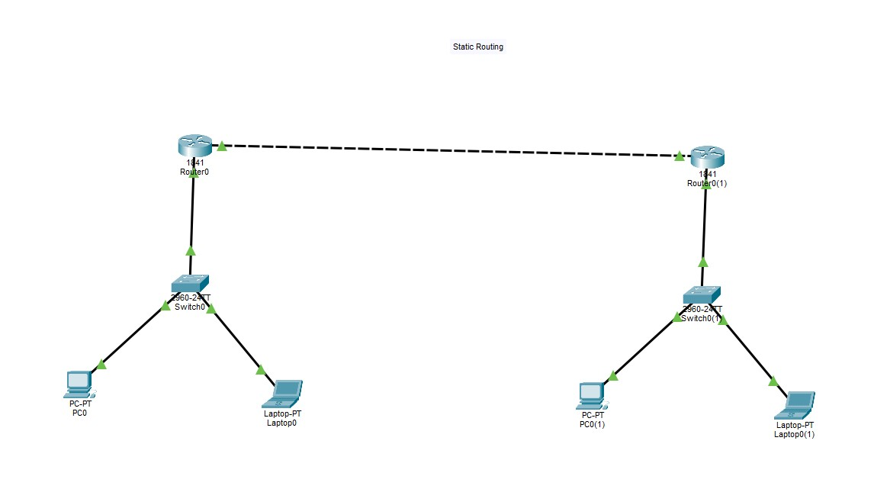
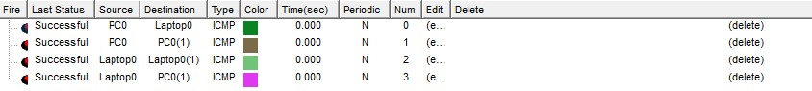
In this lab task, I configured a basic static routing network using two routers connected through a serial interface. Each router is connected to a switch, which in turn links to a PC and a laptop within its respective local area network. Static routes were manually defined on both routers, enabling communication between the separate LANs. The switches facilitate smooth local connectivity, while the routers manage data exchange across networks. This setup highlights the core principles of static routing and demonstrates how devices on different networks can communicate using manually configured routes.

Task-3:
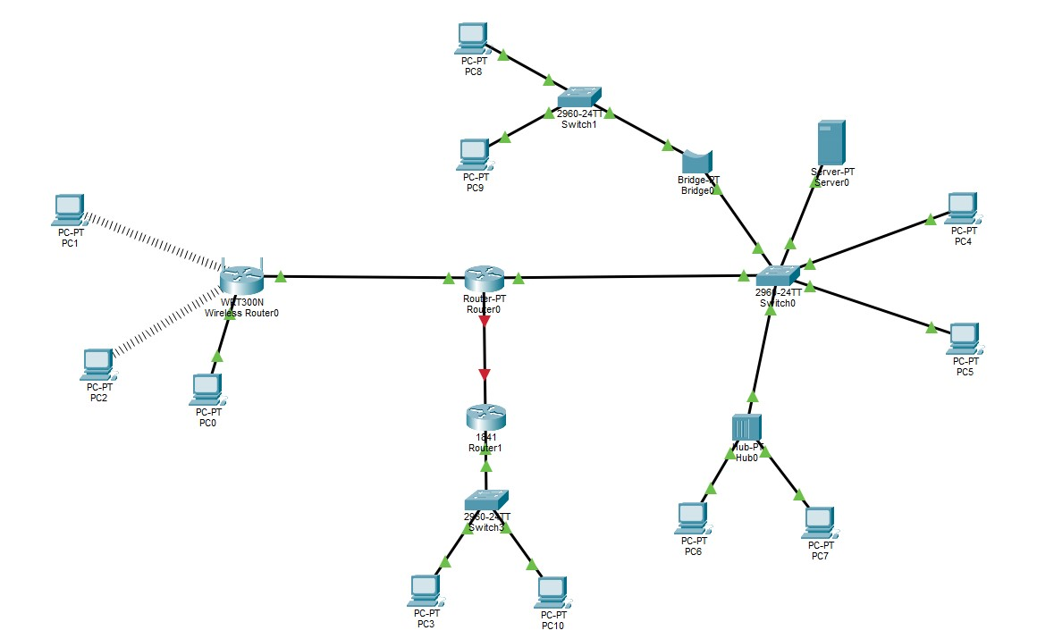
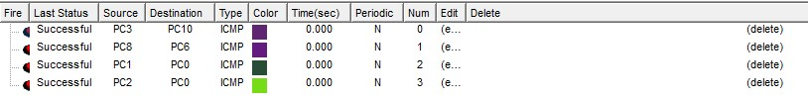
In this lab task, I developed an extended network architecture that integrates both wired and wireless communication using a combination of routers, switches, hubs, and a bridge. A wireless router forms the first subnet by connecting several wireless PCs along with a wired PC. This network is linked to other subnetworks through a main router, which is further connected to additional switches and another router. A bridge and a central switch manage the distribution of connections to multiple PCs and a server, ensuring efficient data flow. To illustrate shared-medium networking, a hub is included to connect extra devices. This comprehensive topology demonstrates a scalable, multi-segment network design that employs both static and dynamic IP configurations for seamless device connectivity.

